[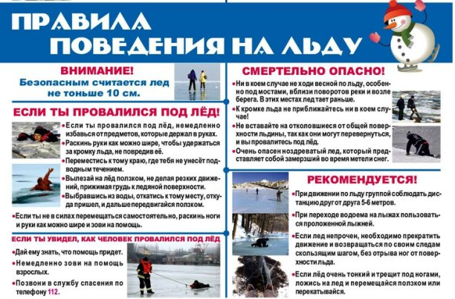](https://ok.ru/dk?cmd=PopLayerPhoto&st.layer.cmd=PopLayerPhoto&st.layer.plc=mediaTopic&st.layer.photoId=930363567585&st.layer.type=GROUP&st.layer.sphotoIds=930363567585%3B930363575521%3B930363585761&st.cmd=userMain&st._aid=GroupTopicLayer_openPhotoLayer)

[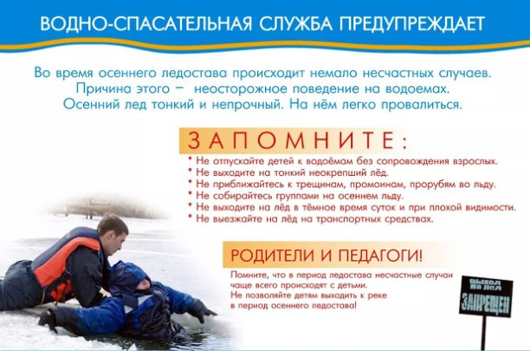](https://ok.ru/dk?cmd=PopLayerPhoto&st.layer.cmd=PopLayerPhoto&st.layer.plc=mediaTopic&st.layer.photoId=930363575521&st.layer.type=GROUP&st.layer.sphotoIds=930363567585%3B930363575521%3B930363585761&st.cmd=userMain&st._aid=GroupTopicLayer_openPhotoLayer)

[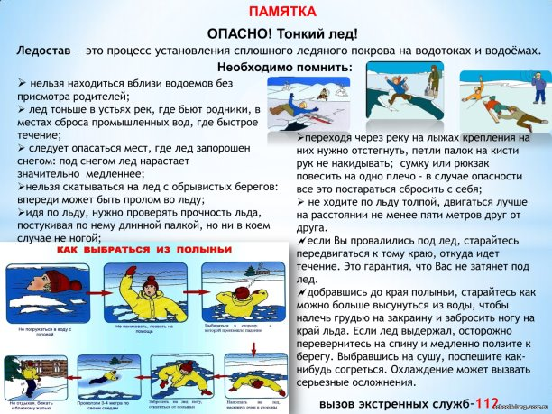](https://ok.ru/dk?cmd=PopLayerPhoto&st.layer.cmd=PopLayerPhoto&st.layer.plc=mediaTopic&st.layer.photoId=930363585761&st.layer.type=GROUP&st.layer.sphotoIds=930363567585%3B930363575521%3B930363585761&st.cmd=userMain&st._aid=GroupTopicLayer_openPhotoLayer)